EYFS News

Early Years Foundation Stage Newsletter, January 2025



Happy New Year from the EYFS team

Special days in class for the children
As we head into the spring term we would like to offer our continued reassurance that your child’s safety, happiness and learning is our priority. Class teams have got to know your children well and the best way to support them during their school day. We are all looking forward to the new term and wish you all a very happy year ahead!

Class teams will be planning lots of exciting activities linked to the following special events. Information will be provided via the home school diary.

Chinese New Year celebrations
24th January

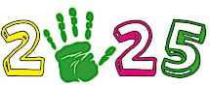

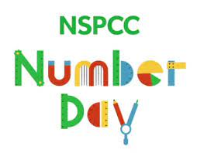
NSPCC Number Day 7th February



My Toys


Your child is at the centre of their learning as we move through our “All about me!” theme. ‘My Toys’ is the aspect of the theme that will be linked to planned activities this term. Do keep us updated via the diary if your child has shown any new interests in toys or activities at home.

Safer Internet Day
11th February


Pancake Day
4th March



World Book Day
6th March
Coffee Morning

We look forward to meeting with parents and carers for our spring coffee morning – it is a great opportunity to get together to have a chat and share ideas. This will take place on Wednesday 26th February (letter to follow).

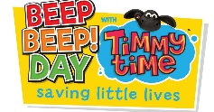
Beep Beep Day 19th March

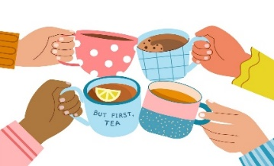

We will also be exploring religious and cultural events linked to Ramadan, Eid, Holi and Easter and taking part in a Science Week.
Red Nose Day
21st March

Early Help

Our Early Help offer can be found on the school website under the key information tab.

Early Help packs are also available from Lianne, our Pupil and Family Liaison Worker. Lianne is based in our Family Room and can provide support, advice and information to families.

Please do not hesitate to get in touch with either Liz, Sam or Lianne if you have any questions, queries or concerns.

.


Uniform Bank

We have a uniform bank based within the Family Room. There is plenty of stock, including t-shirts, jumpers, zipped fleeces, trousers, joggers and dresses.



Don’t forget to check out our website (https://www.thebridgeschool.co.uk/)
which will provide you with lots of information including term dates, a Parental Links Support button, where you will find lots of information around E Safety and how to stay safe online.

There is also a link to the SEND Local Offer website: (www.telfordsend.org.uk).

The Local Offer aims to bring together useful information across education, health and social care within one website. You can find information, advice and guidance and a range of local service providers who support children and young people with Special Educational Needs and Disabilities.

If you need anything, please pop in and see Lianne or you can telephone her, and she can send some uniform home.

Outdoor Play / Gardening

We wish to offer a wide range of both exciting indoor and outdoor activities. To enable us to get the most from the outdoor activities we would be grateful if parents could send in a pair of named wellies (where appropriate), waterproof trousers / puddlesuit. Children will also need a suitable coat.









If you have any worries or concerns about your child please do not hesitate to let us know. We want to work with you to support them. Thank you for your support, the EYFS team.

Your child will have opportunity to participate in the supervised teeth brushing programme ‘Brilliant Brushers’ this term. Information and consent letters to follow in the diary.

