Secondary Phase Newsletter
Spring 2025

(KS3 – Bases 19, 17a,16a and 14)

Welcome back to all pupils after the Christmas break.
We hope you are all well. There are many exciting activities planned for pupils to experience and work on across the curriculum and the overview of these is outlined below.

English

Below are some of the books that will be read this term and include both fiction and nonfiction.

- The Journey by Scott Mann and Neil Griffiths.
- Popalong Hopcorn, Poem by Judith Nicholls.
- The Global Garden by Kate Petty and Jennie Maizels
- You Can’t Call an Elephant in an Emergency, by Patricia Cleveland Peck and David Tazzyman.
- Paddington at The Tower by Michael Bond.
- Ultimate Spotlight: Firefighters by Annie Sophie Baumann.


All books are accompanied by a variety of props to support enjoyment of the text.

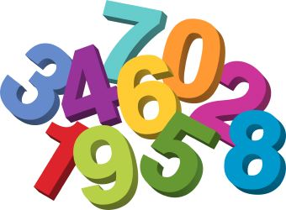
Maths

Pupils will take part in maths activities that build on previously learnt skills and target new learning. They will be accessing number activities to develop counting skills and recognition of number through playing number games as well as sorting/matching activities. They will also take part in activities to use their senses, work on problem solving skills and early attention and awareness tasks. Teachers will personalise learning activities for each pupil with personalised objectives to support small step progress.


PE –Fundamental Skills of Movement – Can you kick it? The aim is to improve students’ technique and performance in a wide range of sports and activities inlcuding foot golf, foot skittles, football, jumping, running and striking with feet.



Science – Plants. Pupils will be exploring objects and materials related to plants, growing plants and exploring what plants need to survive. The topic will provide a wealth of sensory exploration, through a range of activities e.g. Nature feely bags, sensory bottles, exploring the wild area, leaf collages, bark rubbings and flower pressing.

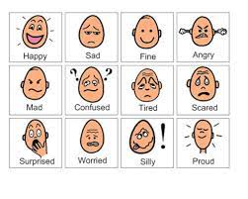
PSHE/Citizenship – Emotions. For some pupils there will be a range of activities and resources that will support them in understanding the emotions of themselves and others. For other pupils PSHE will focus on areas such as Musical Interaction, Sensology or drama games.

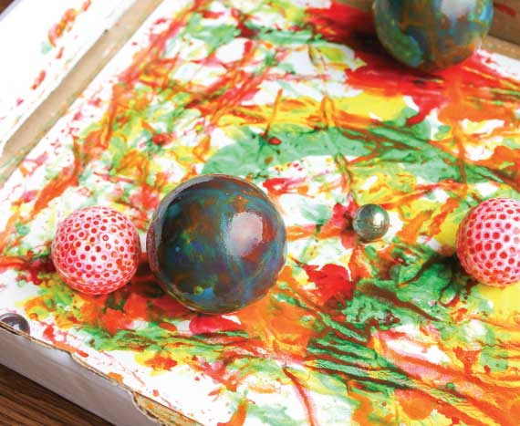
Art –Journeys. This module will look at a range of sensory exploration activities. Pupils will have the opportunity to paint with a range of equipment, such as cars, rollers, balls and tools. Smell and sound will be incorporated into the lessons to support the sensory aspects of the curriculum as well as some favourite stories. Pupils will work with a range of media to produce art in a painted welly walk, a painted feet walk, art in sand and sensory umbrellas.


Music –The Classics. Exploring making music using percussion instruments as well as music technology and resonance equipment. Musical Interaction, vocalisations and Dance Massage will also feature in the activities pupils will be involved with this term.

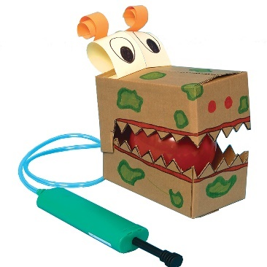
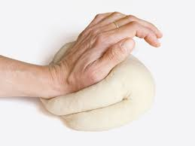
Design and Technology - Pizza. Teachers have planned a range of activities to support the investigation process of making pizza dough. Pupils will take part in many sensory activities that begin with hand awareness, tactile exploration of a range of ingredients, mixing, manipulating and then making pizza and tasting and evaluating the items produced. The second half term will have a focus on Moving Monsters with a chance to explore simple pneumatic systems.


RE – Islam. This topic is about ideas, concepts, stories and artefacts used in a multi-sensory way and linked to the faith of Islam. Pupils will explore the Islamic creation story, place of worship, stories from the Quran and weddings.

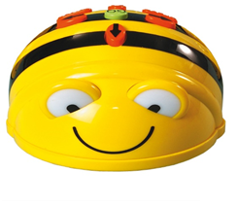
Computing – Computer Science. This will incorporate all aspects of experiential ICT such as listening, cause and effect, looking/ tracking and scanning and reach and touch. There will be the opportunity to take part in a range of activities to control devices at the level appropriate to the pupil’s learning and may include use of hardware such as Bee Bots, remote control cards, Sound Beam, switch toys.


Business and Enterprise – Life on Land. Pupils will be focusing on the careers element of Enterprise in relation to sustainable development and sustainable use of terrestrial ecosystems to enable the protection of threatened species. The sessions will culminate in the pupils running an Easter market with pupil made items for sale. Dates and invites to follow.

 Hobbies and Careers – Over this academic year all pupils will visit the local community, wider community and focus on an activity within school taking a term for each of the above. This will include dog walking and walking locally, a walk in Apley Woods and either film making, active games or relaxation/yoga. A record of experiences are then collated over the year and this builds year on year.

Snacks – We ask that all parents of children who eat a snack in school contribute £10 towards the snacks for this term please. We continue to offer a variety of healthy snacks (appropriate to individual needs) including fruit.

Messages to the class teacher can be sent via the Home School Diary. It is lovely to hear what pupils have been doing at home in the evenings and over the weekend as this can be a cue to communication in class.

Don’t forget to check out the Parental Links Support button on our website. Here you will find lots of information around E Safety and how to stay safe online.

We wish you all a lovely Spring Term
from Mandy James (Head of Secondary Phase), Claire Beckett (Senior Teacher) and all the secondary phase teachers and supporting staff.

